**Branching Minds – Behavior Log Entry Directions**

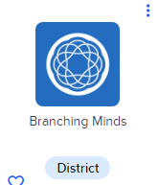Log in through Clever, select Branching Minds.

Select the student you are making the log entry for.

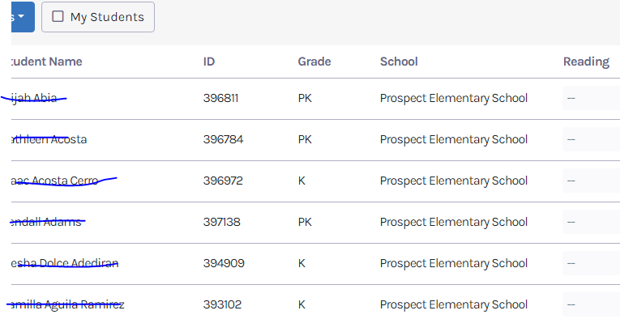

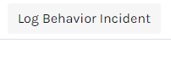Press log behavior incident in the top corner.

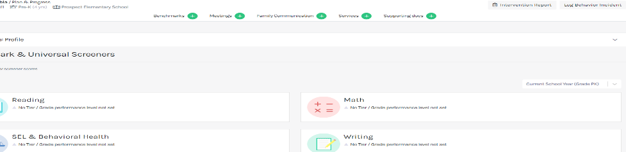

Fill out the details of the incident as specifically as possible. Make sure to note date & time of incident, student name, incident type, and write up an incident description, location, and actions taken (can select more than one). You can also upload any pictures/documents in the log.

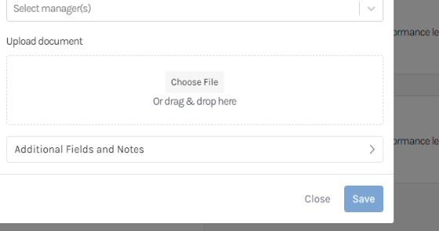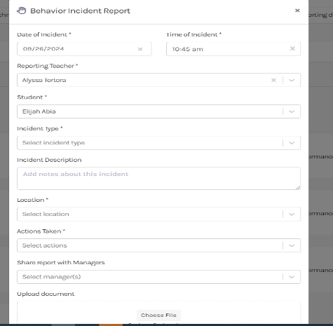

Press save on the bottom.